**sBrooklyn torah gazette**

**For parshas devarim 5780**

Volume 4, Issue 42 (Whole Number 194) 4 Menachem Av 5780/ July 25, 2020

**Printed L’illuy nishmas Nechama bas R’ Noach, a”h**

**Sages through the Ages**

**Rav Zadok HaKohen**

**By Dr. Benji Schreiber**

**[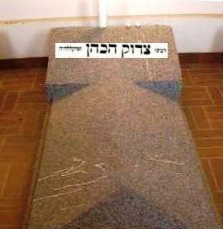](https://images.hamodia.com/hamod-uploads/2018/08/9-Elul-Rav-Tzaddok-Hakohen-1.jpg)**

**The kever of Harav Tzadok Hakohen, zy”a, in Lublin.**

(Kreutzburg, Russian Empire, 1823 – Lublin, Poland, 1900 )

Rav Zadok Ha-Kohen Rabinowitz (1823-1900) was born into a misnagdic rabbinic family in what is today Jēkabpils, Latvia. It is related that he was a remarkable illuy. He lost his father when he was six and then lived with his uncle. Apparently, Rav Yitzchok Elchonon Spektor of Kovno (1817-1896) quizzed him when he was aged 8 and declared he will be a gadol. A few years after his teenage marriage, rumours about his wife’s problematic behaviour reached him. Some say jealousy caused others to intentionally try and disrupt his shalom bayis. In any case, Rav Zadok wanted to divorce her and she refused. He travelled around Europe to acquire the signatures of one hundred Rabbonim to allow him to remarry, even if his wife remained adamant. During his travels, he met many of the gedolim of his time.

It is related that Rav Chaim of Sanz (1797- 1876) told him that he sees with ruach hakodesh that his wife is innocent and if he divorces her, he’ll have no children. The Chidushei HaRim would not sign. When he met Rav Mordechai Yosef Leiner (1801-1854), the Izbitzer Rebbe, he quickly became a chassid. Ultimately, his wife did accept the divorce. The Izbitzer Rebbe then arranged his shidduch with Chana Devorah, although he never had children. His continued learning was supported by his father-in-law and later by his wife’s business in second-hand clothes.

When the Izbitzer passed away, his followers split between his son, the Beis Yaakov, and his talmid Rav Leibele (Yehuda Leib) Eiger, grandson of Rabbi Akiva Eiger. Rav Zadok went with the latter group. Rav Zadok entered a period of shtika – silence – which lasted thirty years.

He spoke to very few people and spent his time learning alone and writing seforim. He responded to only a few letters. During this time, Rav Leibele gave him great respect and gave him matnos kehunah, the parts of the animal due to the kohen.

When Rav Leibele Eiger passed away in 1888, Rav Zadok became Rebbe for the remaining 12 years of his life. During this time, he was a charismatic leader, teaching Torah to thousands of chassidim.

**Works**

He was very prolific and wrote on a broad range of topics in halacha and machshava. Halachic works include: ‘Tiferes Tzvi’ on Yoreh Dea; ‘Levushei Tzedaka’, a defence of the Levush; ‘Otzar Ha-Melech’ on the first book of Rambam’s ‘Mishneh Torah’; and ‘Meishiv Tzeddek’, a defence of the practice to eat a meal inside the house on Shemini Atzeres.

He wrote ‘Takanas Ha-shavin’ on teshuva; ‘Yisrael Kedoshim’ on the unique status of the Jewish people; ‘Sichas Mal’achei Ha-Shares’ on angels; ‘Resisei Layla’ and ‘Machshavos Charutz’ around the holidays; ‘Divrei Soferim’ and ‘Tzidkas Ha-Tzaddik’ contain insights based on Gemoro. ‘Divrei Chalomos’ outlines novel insights that came to him while dreaming. He also wrote on algebra, astronomy and engineering.

**Beliefs**

In interpreting Chazal, he looked for intrinsic connections between Talmudic statements and their exact location in Shas. For example, the Churban appears in Maseches Gittin because it is akin to HaShem divorcing Klal Yisroel, but it is in perek HaNizakin because it can be restored.

Rav Zadok describes a historical phenomenon he calls “zeh le’umas zeh” - literally, ‘this opposed to this’. In the generation of Moshe Rabbeinu, we had Bilam. A generation that desires to know the future produces both prophets and fortune tellers. A time period which emphasizes the abilities of the human intellect witnesses the rise of the Oral Law, as well as the ascendency of Greek wisdom.

He describes a development from the time of dominated by nevuah and Written Torah to a time of chachamim and Torah she’baal peh, which continues to be revealed. He argues (Tzidkas HaZadik 40) that part of teshuva is realising that even sins were HaShem’s will, a perplexing position.

Rav Zadok explains that Torah shebichsav is thisworldly and hence reference to the next world is in Torah shebaal peh. His was a gushing fountain of original creative Torah thought, combining intellectual study with mysticism. He influenced later Rabbonim including Rav Yitzhak Hutner, Rav Gedaliah Shorr and Rav Eliyahu Dessler.

*Reprinted from the Parshat Mattos-Masei 5780 email of Oneg Shabbos (London, UK).*

**Rabbi Berel Wein**

**On Parshat Devorim**

**By Rabbi Berel Wein**

Our great teacher Moshe begins his final oration to the Jewish people in this week's Torah portion. He reviews for them the history of his stewardship of the Jewish people over the past 40 years. He recounts the miracles and tragedies that befell the Jewish people, from the Exodus from Egypt until the very day that they now stand at the banks of the river Jordan preparing to enter the land of Israel.

It is a very detailed oration. Apparently, all the major events and issues, the highs and lows of the sojourn of Israel in the desert of Sinai, are remembered and recounted. He spares no detail or criticism as to what went wrong, and at the conclusion of this book, his love for the Jewish people is fully on exhibition by the manifold blessings that he bestows upon them.

Moshe mentions the heroes that arose to champion the cause of Torah and the Jewish people at moments of crisis, and he also tells us of those who fell short, i.e. how their acts of commission or omission led the Jewish people astray. He points out that heavenly guidance nurtured the Jewish people during this entire long span and assures them that the Creator will not abandon them in the future.

c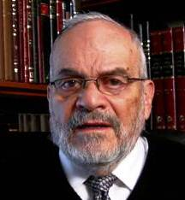

**Rabbi Berel Wein**

**The Creator will Hold Them Responsible**

But he also says that the Creator will hold them responsible for their behavior and their loyalty to Torah. What is striking to me is that Moshe omits any mention regarding the construction of the Mishkan/Tabernacle from his recollection of the history of the Jewish people in Sinai. Yet, in the text of the holy Torah itself, a great deal of space and detail is devoted to this subject. All the commentators are hard-pressed to understand why many eternal commandments are merely mentioned or hinted at, while the construction of the Mishkan/Tabernacle occupies a great deal of space and detail.

Though I have not found many Torah commentaries that discuss this omission, I have myself have thought about it at some length. I think that Moshe is communicating to us a subtle but vital lesson that will enable the Jewish people to survive national loss and destruction, exile and dispersion, and yet be able to rebuild itself physically and spiritually. Moshe is teaching us that all physical structures, though they are the holiest of all human endeavors endowed with godly spirit, so to speak, they are nevertheless only temporary.

The Mishkan/Tabernacle lasted for hundreds of years in the desert and at Shilo in the land of Israel, but it eventually disappeared. The First Temple stood for 410 years but it too became only ruins. The Second Temple, which Herod rebuilt in enormous splendor and was one of the wonders of the ancient world, stood for 420 years. But it also was destroyed and disappeared.

It is not the physical structure of buildings that has preserved the Jewish people until our very day. It is, rather, the Torah, its values and commandments, its worldview and systems of life that have enabled the Jewish people to survive and eventually prosper and rebuild themselves.

It is no accident that the majority of Jewish scholars follow the opinion that the third Temple will not be built by human beings, because it has to be eternal, and all human construction, no matter how grand, noble or lofty still remains only a temporary structure. Moshe, in his oration, speaks not only to his generation but to all later generations of the Jewish people. He does not dwell on physical structures which are always subject to ruin and replacement, but on the spiritual greatness of the eternal Torah that the Lord has bestowed upon the Jewish people.

*Reprinted from this week’s website of Rabbiwein.com*

**Parshas Devarim**

**I Hate Criticism**

By Rabbi Bentzion Shafier

Founder of TheSmuz.com

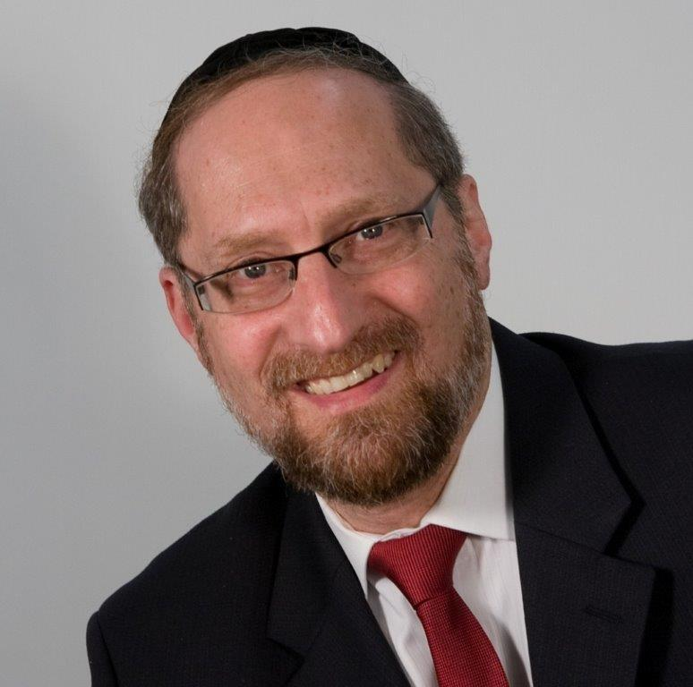

**Rabbi Bentzion Shafier**

“*And it was in the fortieth year, in the twelve month, on the first day of the month, when Moshe spoke to the Bnai Yisroel according to everything that HASHEM said to them*.” — Devarim 1:3

Moshe only rebuked the Jewish people at the end of his life

When Moshe Rabbeinu was near the end of his life, he gathered the Klal Yisroel together to give them rebuke for the sins they committed in the forty years of wandering in the desert.

Rashi is bothered by why he waited. Why didn’t he rebuke them years earlier when the events first took place? Rashi answers that Moshe learned from Yaakov Avinu. Yaakov didn’t admonish his son Reuvain until he was close to death.

“If you are wondering why I didn’t admonish you all of these years,” Yaakov told Reuvain, “it’s because I was afraid that if I did, you would leave me and cling to my brother Aysav.” Therefore, Yaakov waited until he was about to die and only then did he chastise Reuvain. Moshe learned from Yaakov, so he too didn’t give rebuke to the Jewish nation until he was about to die.

This Rashi is very difficult to understand. Why would Yaakov be afraid that if he criticized Reuvain, it would cause him to leave and cling to Aysav? First off, it is difficult to imagine a relationship of love, mutual respect, and dedication that was greater than the one that Yaakov and his oldest son Reuvain shared.

Aside from the natural sense of attachment of a son to his father, Reuvain accepted his father as his teacher, mentor, and spiritual guide. Surely, that should have allowed Reuvain to know that his father’s rebuke was only for his good.

Furthermore, whenever Yaakov spoke to his son, it was with love and sensitivity. If a situation arose where Yaakov felt his son erred, a mature person like Reuvain would willingly accept words of guidance and correct his ways. Why should Yaakov have been afraid?

**The Damage of Criticism**

The answer to this question is based on the effect that criticism has upon a person. The Orchas Tzadikim (Shaar 12) explains that when you verbally attack me, it is a given that I will retaliate. It isn’t much different than if you were physically assaulting me. I perceive your words as an attack against the essence of me, and it is almost within the category of **self-defense** for me to strike back at you. Every fiber of my being screams out to defend myself against the onslaught of your words.

Criticism is but one step below a verbal attack. It isn’t quite as pointed, not quite as aggressive — but not that far off. When you criticize me, I am under attack. The essence of me, who I am, and what I stand for is being assaulted. You may not have intended it that way, but that is what I feel.

There is a powerful sense of disapproval and condemnation that comes across, and I feel under attack. No one likes to be criticized, and the easiest course is to avoid the pain by pulling away. The greater you are in my eyes, the greater the damage of your words, and the more they will drive a wedge between us.

**Why Yaakov was Afraid to Criticize Reuvain**

This seems to be the answer as to why Yaakov was so afraid to criticize Reuvain. Despite the fact that Yaakov would only have intended it for his son’s good, and despite the fact that Reuvain was looking for direction from his loving father, if Yaakov had rebuked Reuvain, he was afraid that it would have forced them apart, damaging the relationship, and perhaps even going so far as to drive Reuvain away. The sense of disapproval that Reuvain would have felt would have been so difficult to bear that Reuvain might well have run away to avoid it, even going so far as joining Aysav.

This is a powerful illustration of the damage caused by rebuke. Even in a relationship based on mutual love and respect, criticism undoes the bond and causes a separation. Here we see it with a mature man whose priorities were straight, a man who lived his whole life for growth and recognized his father as the spiritual guide of the generation. Yet words of rebuke could have had the effect of separating and causing even such a man to go off the path.

**If for Great People, how**

**Much More so for Us?**

If this concept is true for people as great as the Avos, how much more so for us? The reality is that we humans are very sensitive; we hunger for approval and despise rejection. When you criticize me, it may not be your intention, but I feel unwanted and unaccepted. I feel that you don’t approve of me, so I am not respected in your eyes.

That emotion is very difficult to bear. The easiest course is for me to run away — away from the situation, and away from you. For that reason, criticism is poison to all relationships. As a parent, it is one of the most noxious elements that can ruin an otherwise strong relationship. As a spouse, it can be the wedge that drives apart an otherwise happily married couple. And amongst friends, it can be the force that ends an otherwise nurturing relationship.

**3 Rules of Criticism**

For that reason, before a person sets out to criticize, he should remember the three cardinal rules of criticism. The first rule is: don’t do it. The second rule is: don’t do it. And the third rule is: don’t do it.

Don’t do it because it hurts. Don’t do it because it distances people. Most of all, don’t do it because it doesn’t work.

Even if your intentions are to help, and even if you only mean these words for the good of the recipient, criticism is a powerful separator that accomplishes no good, merely drives people apart, and should be avoided like the plague.

For more on this topic please listen to Shmuz #53 - I Hate Criticism

*Reprinted from this week’s website on TheShmuz.com This is an excerpt from the*[*Shmuz on the Parsha book*](https://theshmuz.com/product/shmuz-on-the-parsha-book/)*.*

**The Reward for Believing**

**In G-d’s Promise to Give**

**Us the Land of Israel**

From the Talks of the Lubavitcher Rebbe

Rabbi Menachem Mendel Schneerson, Zt”l

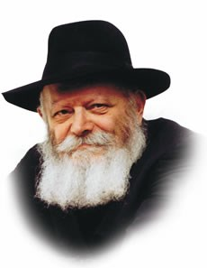

"See, I have set the land before you," Moses relates in this week's Torah portion, Devarim. "Come and possess the land G-d swore unto your fathers."

Rashi, the foremost Torah commentator whose explanation on the text expresses its most literal meaning, explains that the Jewish people did not have to wage war in order to take possession of the land of Israel; had they not sent the spies, they would not have needed any weapons.

"There is no one to contest the matter," Rashi comments. Since G-d Himself promised the land to the Jews, no one in the whole world could have prevented this from happening.

Historically, however, we see that instead of a miraculous entry into the land, the Jewish people did indeed engage in battle with their enemies. Their lack of faith and insistence that Moses send spies to bring back a report, spoiled their opportunity to enter the land unopposed, and made it necessary for them to follow a natural procedure instead of a miraculous one. In other words, it was their own negative attitude and conduct which forced them to wage wars in order to assert their Divine right to the land.

**A Moral for Our Own Times and Present Condition**

This contains a moral for our own times and present condition:

The Torah tells us that the Final Redemption with Moshiach will be very much like our first redemption from Egypt, but will be accompanied by even more wonders and miracles. It follows that if the entry and settlement of the land of Israel was supposed to be accomplished in a supernatural manner the first time ("There is no one to contest the matter, and you need not wage war"), how much more so will it be miraculous in our own times, with the Messianic Redemption!

Again, just as before, the entire matter depends on us. We must show absolute faith in G-d and His promise that the entire land of Israel belongs to the Jewish people. We must not be afraid to inform the nations of the world -- unequivocally -- that the land of Israel is our eternal legacy.

**The Whole Earth Belongs to G-d**

As Rashi explains on the very first verse of the Torah, "The whole earth belongs to G-d; He created it and gave it to whom He saw fit. [The land of Israel] was given to [the nations] by His will, and by His will He took it from them and gave it to us!"

When we will demonstrate this true and absolute faith in G-d, we will immediately merit that "no one will contest this, and there will be no more wars nor the need for any weapons."

*Reprinted from the Parshat Devorim 5755 edition of the Lubavitch Youth Organization. Adapted from Likutei Sichot of the Rebbe, Devarim 5747.*

**Thoughts that Count**

*And I charged your judges at that time, saying, Hear the causes between your brethren* (Deuteronomy 1:16)

It is only during the present era, "at that time," that it is necessary to listen to both sides of a dispute to reach a just decision. When Moshiach comes and ushers in the Messianic era, judgment will be rendered through the sense of smell, as it states, "He will smell the fear of Hashem, and he will not judge after the sight of his eyes and decide after the hearing of his ears." *(Kedushat Levi)*

*Reprinted from the Parshat Devorim 5755 edition of the Lubavitch Youth Organization. Adapted from Likutei Sichot of the Rebbe, Devarim 5747.*

**The Way to Ruin Your Children’s Future**

**By Rabbi Eli Mansour**

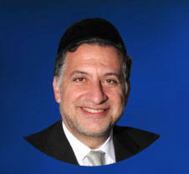

The Haftara read on Shabbat Parashat Tazria-Mesora is taken from the Book of Melachim II and tells the story of four Mesoraim – people stricken with the Sara’at skin infection, which made them impure and required them to reside outside their city. These Mesoraim were outside the city of Shomron during a period of siege, and the story goes on to tell how they discovered the great miracle that G-d performed to rescue the city.

Our Sages identify these four men as Gehazi and his three sons. Gehazi was the disciple and personal attendant of the prophet Elisha, and he was stricken with Sara’at for a grave sin which he committed.

As we read earlier in Melachim II (this section is read as the Haftara when Parashat Tazria is read by itself), Elisha miraculously cured the Sara’at of the gentile general Na’aman, who then offered to pay the prophet a huge reward. Elisha refused to accept any payment, but after Na’aman left, Gehazi ran after him and falsely told him that Elisha changed his mind. Gehazi’s act of greed and deceit was prophetically revealed to Elisha, who decreed that Gehazi and his children would be stricken with Sara’at. These were the three afflicted men who were residing outside the city of Shomron during the siege.

The question arises, why were Gehazi’s children punished? Why did they suffer from Sara’at because of the sin their father committed? Rav Yaakov Kamenetzky (1891-1986) once asked, why is the Jewish Nation not producing great Torah sages? There are so many children enrolled in Yeshivot studying Torah at a high level. Why are they not becoming outstanding scholars?

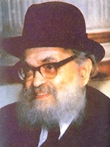

**Rav Yaakov Kamenetzky**

He explained that the reason is because of the lunch the children are eating. When the schools send the parents the applications for government subsidies for their children’s lunch, the parents give false information about their income in order to qualify for the discounts. Their children thus end up going to yeshiva and eating stolen food for lunch. And a child eating stolen food in yeshiva will never grow to become a great scholar. This explains why Gehazi’s children were stricken with Sara’at like him.

He was greedy and sought to acquire wealth through dishonesty. When a person lives this way, he ends up raising his children with stolen money. This has a grave effect on their inner beings, and they, too, become sinners.

People who deal dishonestly in business or in conducting their financial affairs justify their wrongdoing by claiming that they are concerned about their children’s future.

The truth is, however, that dishonesty is the way to destroy one’s children’s future. We ruin our children’s prospects for greatness if we raise and support them, and pay their Yeshiva tuition, with ill-begotten gains.

The best way to care for our children’s future is by living as honest, upstanding, observant Jews, as the Torah tells us to live, and trusting that Hashem will care for us and our families.

*Reprinted from the archives of iTorah.com*

**A Heavy Rain and**

**An Unexpected**

**Knock on the Door**

**By Rabbi David Ashear**

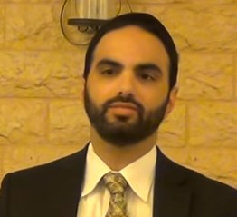

Some people endure years of pain. We don’t know why, but Hashem does. We don’t know what we are accomplishing with each day that goes by in our current situation. We do know that it is tailor made for us, and Hashem is guiding us every step of the way.

Just knowing that we are not victims of circumstance can improve the quality of our lives immensely. There are people who are ready to give up on life, עלינו לא , as a result of constantly second-guessing themselves. They would feel so much better, if only they would know that Hashem is with them, holding their hand and giving them exactly what they need for their own benefit.

Rabbi Elimelech Biderman told a story about Rabbi Yosef Palech, from Kiryat Harim Levine, who gave a Gemara shiur to a small group every night in Tel Aviv. The participants were extremely committed to the class, however, one night the weather was so bad, Rabbi Palech was the only one who showed up.

The Rabbi had been giving this shiur for years, without missing a single night, and he didn’t want to start now. He went out to the street in an attempt to find someone to teach. However, nobody was outside.

He said, “Please Hashem, help me find someone.” He crossed the street and approached an unkempt house that bore a Mezuzah and knocked on the door. A man who was clearly not observant opened the door, exposing the foul-smelling untidy interior.

Nevertheless, the Rabbi politely asked, “I was wondering whether you would be interested in learning Torah with me tonight.”

The man opened his eyes wide and tearfully shouted, “Who brought you here? Come in!” The man began to cry, telling the Rabbi his life story.

“After the war, I was a lone holocaust survivor. I wanted nothing more to do with Judaism or Hashem. My life has been one long chain of misery. I have nothing in this world. No wife. No family. No Money. Nothing.”

He then pointed to the ceiling where a rope was dangling. “Tonight, I was ready to put an end to my misery. Before I took this drastic step, I cried out, ‘G-d in heaven, if You are here with me and You really want me, show me that You need me and I will come back to You.’

“Since the day I moved into this house, no one has ever knocked on my door. Just moments ago, when I finished my prayer, you came. Yes, I want to come learn with you tonight, Rabbi. Please guide me back to Hashem.”

When Rabbi Palech passed on, this man, who by then was fully observant, came to the Shiva and shared this story with the Rabbi’s family.(I just had this story verified by somebody who was close to Rabbi Palech) Hashem loves all of us, and He is always with us. Life can be difficult; if we realize that everything is planned by Him for our benefit, we would be so much happier.

*Reprinted from the archives of iTorah.com*

**An Almost Endless Series**

**Of Priceless Lectures**

**Featured on TorahAnytime.com**

**By Daniel Keren**

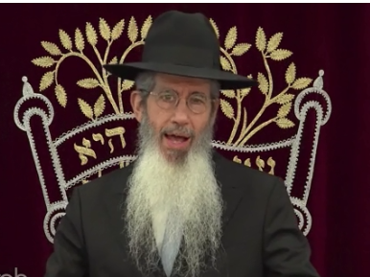

**Rabbi Dovid Goldwasser at the Memorial Day Virtual Hakhel Event**

The world has changed in the last four months since the outbreak of the COVID-19 pandemic in more ways than one could ever have imagined. If anybody had any doubts that there is a Creator who actively supervises His creation and cares about what His creature beings are doing, the forced quarantine and dramatic changes to our lifestyle has no doubt given many an atheist or agnostic serious food for thought.

Here in America, we Jews are finally returning to our shuls for worship services and in most shuls there are signs requesting that all please wear face masks and keep proper social distancing. This is not a pleasant state of affairs, but it does make talking in shul more difficult. And that is certainly an advantage.

**The Advent of Virtual Torah Events**

Still lectures before large audiences as was common in Jewish communities around the world have become Virtual Events that can now be seen by larger audiences than before when just available to those living in the actual community.

One of the major avenues for distributing important Torah lectures is the website Torahanytime.com It was started 14 years ago by two brothers in the Bukharian community in Queens – Shimon and Rubin Kolyakov along with Yosef Davis initially to allow their friends and family the chance to experience Torah classes wherever they might be or whenever a convenient time arose.

Today Torahanytime.com has become the world’s largest library of originally recorded Torah videos in the world, from more than 1,000 Torah educators, including many such as Hacham Ovadia Yosef, Rabbi Avigdor Miller and Rabbi Chaim Yisroel Belsky who are today in the Olam Haemes (the Next World).

Millions of hours of great Torah learning is being accomplished by tens if not hundreds of thousands of Jews around the world. Even for those who were able to attend the actual lecture in person, Torahanytime.com website allows one the ability to listen to a lecture a second or even third time and there is no need to clutter one’s house or automobile with dozens if not hundreds of CD’s.

The Torahanytime.com lectures include 350 hours of new shiurim each week and can be accessed via Live Streamed Events, podcasts, the traditional website and mobile and WhatsApp devices.

**A Great Gift for Those who are Homebound**

This has become a great gift for those who are homebound either due to illness or old age or if your car isn’t working or you don’t want to take public transportation after a tiring day at work or you can’t find a babysitter and you need to take care of your children during the time that the Torah lecture is scheduled.

When you click or google Torahanytime.com’s homepage, at the top of the page you have the options of Speakers, Ladies, Topic and Organizations. Each of these four categories are listed in alphabetical order. To date more than 70,000 shiurim (Torah lectures) by more than a thousand speakers from around the world are available. All of these lectures are available free of charge, although the website does allow one to demonstrate hakoras hatov (gratitude) by making a donation that will allow this important Torah vehicle cover its basic costs.

As mentioned earlier in this review many Torah lectures that prior to the outbreak of the horrific corona virus were viewed by dozens if not hundreds of men and women are now being taped in Virtual reality.

An example of this was the recent Independence Day Flatbush Hakhel Yarchei Kallah Event that normally would have been offered to a live audience at the Agudath Israel of Madison in Flatbush. The shiurim were shown on Friday, July 3, 2020 the legal holiday as July 4th fell on Shabbos Day.

**The World is Changing - Again**

A very timely lecture based on Rabbi Yisroel Reisman’s insights into Sefer Divrei Hayomim Beis (The Book of Chronicles 2) also offered powerful and relevant comments to the current political turmoil racking the United States and the rest of the world. The title of his lecture is most appropriately – “The World is Changing – Again.”

The second lecture of the Flatbush Hakhel Vertical Independence Day Yarchei Kallah was a fascinating examination by Rabbi Doniel Osher Kleinman on “How Halacha Interacts with the Diversity of Medical Recommendations Regarding the Coronavirus.”

In an attempt to make sense of today’s chaos, Rabbi Dovid Goldwasser spoke at the same Hakhel program on the importance of “Emunah and Bitachon in Very Turbulent Times: Practical and Meaningful Guidance.”

Throughout the history of the Jewish people, the Shabbos had been our eternal contract with Hashem. More than the Jews have kept the Shabbos, the Shabbos has kept the Jews going both as a people and as individuals striving to make sense of the crazy world around us.

**Relevant Shabbos Questions**

Completing the Independence Day Hakhel Event in Flatbush as seen by more than a thousand people in more than 120 nations and territiories around the world was a halacha lecture by Rabbi Dovid Ribiat on the important subject of “Contemporary Shailos in Hilchos Shabbos.” It included such relevant inyanim (topics) as how to deal with problematic automatic lights and sinks in hospitals and hotels and what to do when there is rioting in religious neighborhoods.

To view any of the above four lectures, simple click on your computer Torahanytime and at the top of the homepage, click Organizations and then scroll down to Hakhel. After clicking Hakhel, all four lectures will be seen at the top of the Hakhel page.

*Reprinted from the July 17, 2020 edition of The Jewish Connection.*